**For the Week of July 1, 2024**

**Manager’s Message**

Aaron Frank, Town Manager

The Town of Colchester wishes Bryan Osborne a happy and healthy retirement.  Bryan’s contributions over his 33 years as Public Works Director have benefited our natural environment through stormwater and wastewater improvements, bike, pedestrian and vehicular facilities, community buildings and our financial well-being through thoughtful operational and capital planning.  His can-do attitude, work ethic and grantmaking has benefited Colchester for decades and will continue to do so. Thank you, Bryan, for your dedication to our Town!

We thank Alicia Tebeau-Sherry for her amazing work over these last few years. Alicia’s smiling face and warm disposition greeted many residents when they visited the Town Manager’s office. She served in the Communications Coordinator role with ambition, enthusiasm and professionalism beyond her years. We wish you the best Alicia in your new endeavors and look forward to seeing you around Town.



*In observance of Independence Day, the Town Offices and the Library will be closed Thursday, July 4th.*

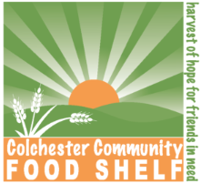

**Colchester Community Food Shelf Donations:** Last week, the food donations from the collection bin at the Town Offices were brought to the Colchester Food Shelf and weighed in at 24 lbs. We wanted to thank the community for giving back! To learn more about the food shelf, please visit: <https://colchesterfoodshelf.org/>

**July is National Parks and Recreation Month!**

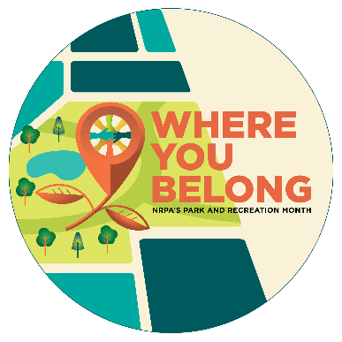This year’s Park and Recreation Month theme — “Where You Belong” — celebrates the many ways park and recreation professionals foster a sense of belonging in their community by providing welcoming and inclusive programs, essential services for all ages and abilities, and safe, accessible spaces to build meaningful connections. We are excited to be expanding our recreational spaces with the new Colchester Recreation Center coming in the near future!

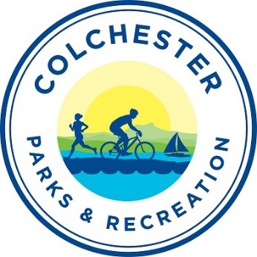Colchester Parks and Recreation offers year-round, multi-generational programming and maintains the community’s recreational areas and facilities. Annual events, like this week’s Fourth of July celebrations or the summer concert series beginning later this month, are wonderful ways to enjoy Colchester Parks and Recreation’s work. If you haven’t utilized Colchester’s parks or recreational opportunities, you can learn more here: <https://colchestervt.gov/333/Parks-Recreation>.

**Come visit the historical Log Schoolhouse!**

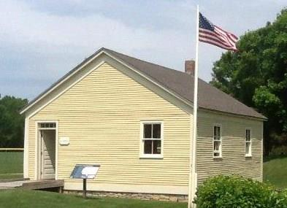**Fridays - Mondays**

**10 a.m. - 2 p.m.**

**Airport Park**

**500 Colchester Point Road**

**Free parking and admission.**

The Colchester Log Schoolhouse (circa 1815) is a lovely museum and information center for visitors of all ages. Enjoy a step back in time to the early days of education in the time before cellphones and computers. A new entrance ramp has been added for improved accessibility. Volunteer hosts are needed, and hours are very flexible. This is a great opportunity to enjoy and share part of Colchester's wonderful local history. Because it's located at Airport Park near the recreation path, you'll meet people from around the United States and the world. For more information and to volunteer, please reach out to Carol Reichard of the Colchester Historical Society at [winchris65@comcast.net](mailto:winchris65@comcast.net).

**About the Colchester Historical Society:** The Colchester Historical Society is a local nonprofit organization dedicated to preserving Colchester’s history. It shares historical information and hosts history-related events within the community. To learn more or become a member, please visit <https://www.colchestervt.gov/422/Colchester-Historical-Society>. Everyone is welcome at programs and events. Membership fees, sales, and donations help support the organization's mission to preserve and share Colchester's wonderful local history.

**Department Updates**

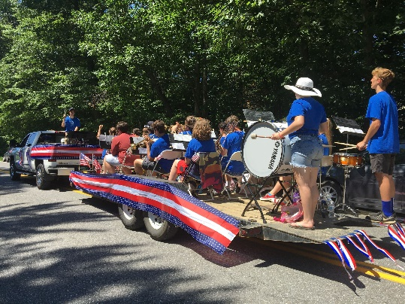**4th of July Celebration: Thursday, July 4, 2024**

**5K Fun Run:**

* $5.00 per participant
* 7:30 a.m. - 8:00 a.m.: Fun Run Registration at Union Memorial School
* 8:15 a.m.: 5K Race Begins - Middle Road

**Parade:**

* The parade starts at 10:00 a.m. at Colchester High School
* Parade Route: The parade will process from Colchester High School, down Blakely Road, and end at Lavigne Road.  Road closure is expected to be approximately one hour

**Bayside Beach:** Lifeguards will not be on duty for the 4th of July.

**Bayside Park:**

* 5:00 p.m. to 9:00 p.m.: Inflatables
* 5:00 p.m. to 9:00 p.m.: Food Vendors
* 6:45 p.m. to 8:45 p.m.: Music Entertainment: **THE HITMEN**
  + The Hitmen are: Jim Cheney (Bass and Vocals), Bob Young (Guitar and Vocals), Brian Donnelly (Drums and Vocals), and Bob Boedecker (Keys and Vocals).
  + Musical Style: 1970s- and 1980s-party rock & roll, featuring hot guitar, organ, and impressive vocal harmonies! The Hitmen play anything from John Mellencamp to Santana, The Atlanta Rhythm Section to Steely Dan - don’t miss this fantastic group!

**Fireworks:**

* Fireworks will take place at dusk from the Bayside Softball Field. Please stay behind the safety fence
* Parking available at: Colchester High School, Colchester Middle School, and Malletts Bay School

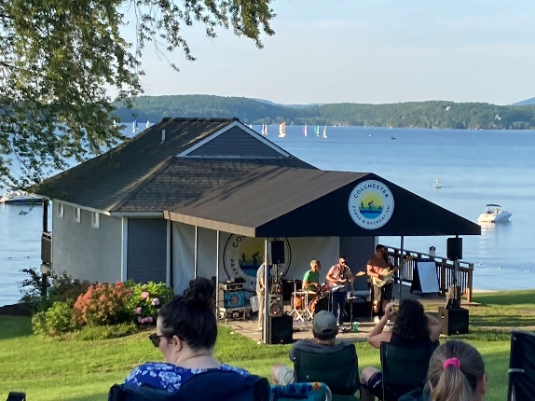**2024 SUMMER CONCERT SERIES:** Join us for Colchester's summertime tradition. Bring your lawn chairs, blankets, and picnic dinner to Lower Bayside Park for our summer concert series on Thursday evenings. Enjoy great music with the beauty of Malletts Bay as your backdrop!

* Lower Bayside Park (Beachside)
* All Concerts begin at 7:00 pm
* Admission is FREE
* Parking available at Bayside Park

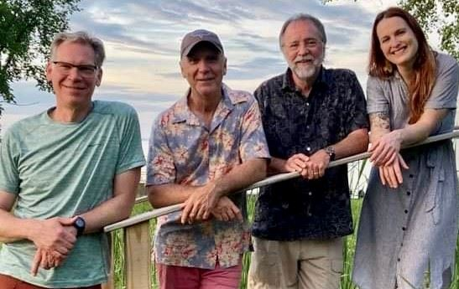**July 11: SHE WAS RIGHT**

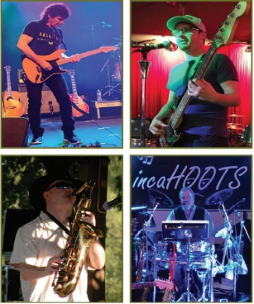She Was Right is a four-member band that consists of Colchester residents Jim Neary (percussion, vocals) Stewart Foster (guitar, vocals), CHS grad Cait Hoffmann (vocals) and from Monkton, Otto Funke (bass, vocals). Over the years, the band has played at numerous local venues and private gatherings, and cover acoustic songs from many artists of various decades including James Taylor, The Eagles, Bonnie Raitt, Alison Krauss and many others. With smooth guitar stylings, and Cait’s beautiful voice She Was Right will engage you in an evening of music that will have you tapping your feet and singing along. As the band says, ‘Bring your thirsty ears’!

**July 18: INCAHOOTS**

“InCahoots” is based out of Plattsburgh, New York and has been providing their audiences with a fresh new look at an American tradition, Entertainment with a smile. A four-piece band consisting of John Geno - Fiddle, Guitar, Sax, Keys and Vocals; Kevin Connelly - Guitar, Keys, Harmonica and Vocals, David Long - Drums and Vocals and Ryan Finney – Bass. Playing genres of music from Charlie Daniels to AC/DC and everything in-between, InCahoots entertains with airtight harmonies, instrumentation and a beat you can really stomp your feet to. Contact John Geno at 518-578-9483 for availability at your venue today!

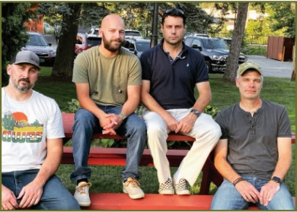**July 25: THE DEVON MCGARRY BAND**

Comprised of four seasoned musicians with common ambitions, The Devon McGarry Band presents an original music endeavor that can’t be ignored. In the ever-changing world of rock music, they seek to be refreshing yet accessible. The music is rooted in McGarry’s heartfelt lyrics and rhythms, but has been sculpted by his bandmates into a movement of sound. For nearly every catchy hook, Jeff Messina (lead guitar) offers up a blistering guitar solo to follow. Mitch Terricciano (bass guitar) and Rich Armstrong (drums) lock in to provide dynamic rhythms and uplifting grooves. Some songs hearken back to the 90’s alternative scene, while others break the mold and blend genres.

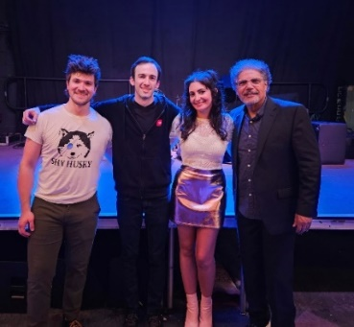**August 1: ALI T BAND**

Alison Turner, better known as Ali T, is an indie-pop singer-songwriter based in Vermont. The 90’s-influenced songstress performs original favorites and puts her own spin on popular tunes. Having started writing songs at the age of seven, and picking up the guitar when she was 11, Ali has developed into an introspective songwriter and versatile performer. Vermont’s Seven Days named Ali T “Best Pop Artist” in 2023 and she has been a finalist for Best Vocalist and Best Pop Artist 2018-2022. She was also a nominee in the New England Music Awards for “Rising Star - Vermont” in 2022 and “Pop Act of the Year” in 2023. Ali graduated from Wagner College on Staten Island.

Ali has released three albums - “Smoke & Mirrors” (2019) with help from Grammy-winning sound engineer Ed Eastridge, “The Makeover” (2021), which is a remastered collection of original songs from her past, and her latest release - the entirely self-produced, “Pancakes At Midnight” (2023). Visit sheisalit.com for music and more.

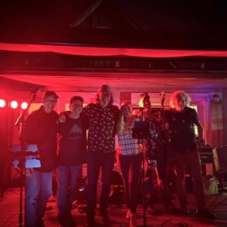**August 8: B-TOWN**

B-town Is a classic rock-n-roll and rhythm and blues band that appeals to all generations. We are not your standard toe tapping band. We play a variety of favorite classics that will get you up and dancing for a night to remember.

**Upcoming Town Meetings & Agendas**

**Selectboard Meeting:**Tuesday, July 23, 6:30 p.m. at the Colchester Town Offices, 3rd Floor Outer Bay Conference Room, 781 Blakely Road. Alternatively, send a note, up to 1,000 words, to [TownManager@colchestervt.gov](mailto:TownManager@colchestervt.gov) with “Citizens to be Heard” in the Subject and your name. As with in-person Citizens to be Heard, we ask that you SHARE YOUR ADDRESS. The email will be shared with the entire Selectboard prior to the meeting and included in the information packet at the next meeting.

* Watch the Meeting Online via Live Stream: <http://lcatv.org/live-stream-2>
* Agenda: [www.bit.ly/Colchester-SB-Agendas](http://www.bit.ly/Colchester-SB-Agendas%20)

**Planning Commission:** Tuesday, August 6, 7:00 p.m. at the Colchester Town Offices, 3rd Floor Outer Bay Conference Room, 781 Blakely Road. Agenda: <https://clerkshq.com/Colchester-vt?docId=PLANAGENDA>

**Recreation Advisory Board:** Wednesday, August 14, 7:00 a.m. at the Colchester Town Offices, 3rd floor, Outer Bay Conference Room, 781 Blakely Road. Agenda: <https://clerkshq.com/Colchester-vt?docId=RecAdv&path=BOARDS%2CRecAdv%2C>

**Development Review Board:** Wednesday, July 10, 7:00 p.m. at the Colchester Town Offices, 3rd Floor Outer Bay Conference Room, 781 Blakely Road. Residents are welcome to attend the meeting or public comments can be submitted prior to the hearing by email to [zmaia@colchestervt.gov](mailto:zmaia@colchestervt.gov) or by mail to Town of Colchester, c/o Development Review Board, 781 Blakely Road, Colchester, VT 05446. Agenda: <https://clerkshq.com/Colchester-vt?docId=DRBAgenda>

**Library Board of Trustees:** Thursday, July 11, 4:00 p.m., in the Burnham Room of the Burnham Memorial Library. Agenda: <https://clerkshq.com/Colchester-vt?docId=LibBoard&path=BOARDS%2CLibBoard%2C>

**Subscribe to the Town Newsletter:** <https://lp.constantcontactpages.com/su/jkMAO2v>

For more information or to comment, call 802-264-5509 or email [townmanager@colchestervt.gov](mailto:townmanager@colchestervt.gov)